**CURRICULUM VITAE**

**Position applied for:** Software Engineer

**Working time / Temps de travail:** + Full time

+ Teleworking

|  |  |  |
| --- | --- | --- |
| **PERSONAL INFORMATION** | | |
| **Full name:** Hoàng Yến | Female, Single |  |
| **Nationality:** Vietnam | |
| **Date of birth:** 17/08/1980 | |
| **Address :**  So 41, Ngo 168, Duong Kim Giang, Hoang Mai, Hanoi, Vietnam ,postcode 128237 | |
| **Cell phone :** (+84)8-68494381 | |
| **Email :** [mailto: yenh999@gmail.com](mailto:mailto:%20yenh999@gmail.com)  **Skype :** yen.mi.nhon  **Facebook** <https://www.facebook.com/vitbau.vit.9> | |

|  |  |  |  |
| --- | --- | --- | --- |
| **EDUCATION** | | | |
| **University** | **Department** | **From -To** | **Degree** |
| International Francophone Institute IFI, Hanoi | Master in Network and Communication system | 11/2013-12/2016 | Master |
| Thang Long University | Mathematics and Computer science | 9/2009-11/2004 | Bac |

|  |  |  |  |  |
| --- | --- | --- | --- | --- |
| **FOREIGN LANGUAGES**  1 beginning 🡪 5 expert | | | | |
| **Foreign languages** | **Listening** | **Speaking** | **Reading** | **Writing** |
| English | 2 | 2 | 4 | 4 |
| French | 2 | 2 | 3 | 3 |

|  |  |  |  |
| --- | --- | --- | --- |
| **SKILLS** | | | |
| **Skills** | | **Months of experience** | **Rank**  **1 beginning 🡪 5 expert** |
| Programming Languages | | | |
|  | C,C++ | 12 | 3 |
| Java | Java | 8 | 3 |
| J2EE | 4 | 1 |
| .Net | ADO.Net | 50 | 4 |
| ASP.NET | 18 | 3 |
| C#.Net | 48 | 4 |
| VB.Net | 12 | 3 |
| Other languagues | VB6 | 4 | 3 |
|
| Web | | | |
|  | Design | 12 | 4 |
|  | JSP | 6 | 4 |
|  | PHP | 2 | 1 |
|  | JavaScript | 12 | 4 |
|  | NodeJS | 6 | 4 |
|  | JADE | 4 | 4 |
| Database | | | |
|  | Analysis & Design | 4 | 5 |
|  | MS SQL Server | 16 | 4 |
|  | Oracle | 8 | 4 |
|  | Postgres | 30 | 5 |
|  | SQLite | 5 | 5 |
| OS | | | |
|  | Unix | 40 | 4 |
| Analysis & Design | | | |
|  | UML | 3 | 2 |
| Others | | | |
|  | XML | 2 | 4 |
|  | Netkit, Openjump, OpenCV… |  |  |

|  |
| --- |
| **REFERENCES** |
| **Name/Nom :** Romain Raffin  **Job Title**: Professor, **Company :** L’IUT d’Aix-Marseille site d’Arles.  **Email :** [romain.raffin@univ-amu.fr](mailto:romain.raffin@univ-amu.fr).  -------------------------------------------------------------------------------------------------------------------**Name:** Nguyen Dang Khoa  **Job Title:** Team leader , **Company:** VKX, Samsung  **Facebook :** <https://www.facebook.com/kevin.nguyen.1441810>  ------------------------------------------------------------------------------------------------------------------**Name:** Nguyễn Trung Hiếu  **Job Title** : Team leader , **Company:** Tinh Van consulting  **Email** : [w3.hieunt@gmail.com](mailto:w3.hieunt@gmail.com)  **Facebook :** <https://www.facebook.com/hieunguyentrung1209> |

|  |
| --- |
| **HOBBIES & EXPECT** |
| **Hobbies:** Traveling, gardening, cycling, fruits  **Expect in job**: Having much challenge in working, opportunity to go abroad |

|  |
| --- |
| **EXPERIENCE** |

|  |  |
| --- | --- |
| **Company**: IoT centre of VNPT technology  **Language environment** : Vietnamese | |
| **Position:** Data engineer | **Main duties:**  Management, analyzing, deploying Big data, Hadoop, Hbase, … |
| **From date:** 01/03 /2017 **To date/đến ngày To date :** now |

|  |  |
| --- | --- |
| **Company**: L’IUT d’Aix-Marseille site d’Arles  **Language environment** : French | |
| **Position:** Interns | **Main duties:**  Internship of master |
| **From date:** 4/2016 **To date/đến ngày To date :** 15/7/2016 |

|  |  |
| --- | --- |
| **Company:** Tinh Van consulting  **Language environment** : Vietnamese | |
| **Position :** ERP software engineer | **Main duties:**  Developing ERP software  Deploying, consulting for client |
| **From date**: 2/2012 **To date:** 10/2012  **Reason for stop working:** Preparing to studying master |

|  |  |
| --- | --- |
| **Company:** ITG Viet Nam  **Language environment** : Vietnamese | |
| **Position :** software engineer ERP | **Main duties:**  -Developing ERP software  -Deploying, supporting, consulting for client |
| **From date:** 8/2009 To date/đến ngày **To date:** 11/2011  **Reason for stop working :**expired contract |

|  |  |
| --- | --- |
| **Company:** R&D center VKX of LG-Nortel  **Language environment** : Vietnamese, English | |
| **Position :** R&D engineer | **Main duties:**  -Researching about telecommunication.  -Coding embedded system application for LG-Nortel’s DECT phone. |
| **From date:** 6/2008 **To date:** 5/2009  **Reason for stop working:** I wasn’t agree with constraints of training contract in Korea. |

|  |  |
| --- | --- |
| **Company/ Société:** Vietsoftware international (VSII is outsourcing company)  **Language environment** : Vietnamese, English | |
| **Position /Titre:** Software engineer | **Main duties:**  Developing web application |
| **From date:** 6/2007- **To date:** 4/2008  **Reason for stop working:** finishing project |
|  | |
| **Company:** Trading and Service Informatics (TSI)  **Language environment** : Vietnamese | |
| **Position:** Software engineer, Team leader | **Main duties:**  - Developing web and window form application, leading a team |
| **From date :** 3/2005 **To date:** 4/2007  **Reason for stop working:** finishing project |

|  |
| --- |
| **PROJECT** |

|  |  |
| --- | --- |
| **Project’s name:** Deploying Big Data  **Customer’s name:** VNPT technology | **Company:** VNPT technology |
| **From date :** 3/2017 | **To date:** |
| **Size (number of taken people):** 2 | **Task:** Studying, deploying, analyzing and managing big data. |
| **Project descriptions:**  **Tools:** Hadoop, Mapreduce, HDPF, Unix : CentOS 6, Database: Hbase. | |

|  |  |
| --- | --- |
| **Project’s name:** Eloquenzior  **Customer’s name:** Centre Camille Jullian | **Company:** A*Midex (Aix-Marseille Initiative of Excellence), Centre National de la Recherche Scientifique CNRS,French |
| **From date :** 4/2016 | **To date:** 15/07/2016 |
| **Size (number of taken people):** 1 | **Task:** Developing, studying theory and proposing the solution. |
| **Project descriptions:**  A client-server Web system for analysis and storage data for archeology. Data are document PDF, Doc, image, keyword, object spatial 3D.  Function:  -Storage and data management.  -Interface for image, documents, 3D objects, and analysis spatial objects.  -Full text search.  -Export data.  -Proposing and implementing the solution for indexing data to increase performance.  **Tools:** NodeJS, Express, Jade, HTML5, JavaScript, shell script, OS: Unix, Database: SQLite. | |

|  |  |
| --- | --- |
| **Project’s name:** Simulation of rescue in case earthquake in city | **Organization:** IFI |
| **From date:** 12/2013 | **To date:** 07/2014 |
| **Size (number of taken people)/ Taille (nombre de membres ):** 1 | **Task:** Developing, studying theory and proposing the solution. |
| **Project descriptions**  Artificial Intelligence multi-agent system SMA for simulation.  Function:  -The simulation for situation of rescue in case earthquake in city.  -Suggesting and implementing the solution to rescue many victims in short time with the low number of die victim.  **Tools** : GAMA 1.5.1, OpenJUMP | |

|  |  |
| --- | --- |
| **Project’s name**: HiStaff  **Customer’s name:** VP Bank, TechCom Bank, HaBu bank, Tran Anh corp...  **Company:** Tinh Van Consulting | |
| **From date:** 02/2012  **To date:** 10/2012 | **Project descriptions:**  HRM application  Function:  -HR management, Salary management: accessing time tracking by access card, Salary calculator formula, history salary…  **Tools**: VS.NET 2008, VB.NET, ASP.NET, Oracle 10i, SVN |
| **Size (number of taken people) :** 3 |
| **Task:** programmer, developing HR module and new function, developing reports. |

|  |  |
| --- | --- |
| **Project’s name:** 3S ERP  **Customer’s name:** Son Duong surgar corp, PVTEX corp, Vina Okamoto corp, Minh cường corp, Elecvina corp, CPN electric supper market,Anh Duc, electric supper market,Bemac corp, Viet Bi capital…  **Company:** ITG Vietnam | |
| **From date:** 12/2009  **To date:** 11/2011 | **Project descriptions :**  ERP application  Function:  -Financial Management, Purchasing Management  -Sales Management, Inventory Management, and Fixed Asset Management, Management human resource HRM, Salary management: accessing time tracking by access card, salary calculator formula, history salary…  T**ools** : VS.NET 2005,C sharp, Postgres8.9, SVN, Crystal report |
| **Size (number of taken people)** 1🡪3 |
| **Task/Tâche:** programmer, developing HR module and new accounting function. |

|  |  |
| --- | --- |
| **Project’s name:** 3S-HRM  **Customer’s name:** Vinasteel corp, Son Duong surgar corp, PVTEX corp, Vina Okamoto corp, Minh cường corp, Elecvina corp, CPN electric supper market,Anh Duc …  **Company:** ITG | |
| **From date:** 8/2009  **To date:** 11/2011 | **Project descriptions**  HR application is Human resource application, this is attractive part in ERP system of ITG  It has dynamic functions as dynamic payroll,  dynamic searching, dynamic report … |
| **Size (number of taken people):** 1 |
| **Task:** main programmer, architect for function and database, testing. |

|  |  |
| --- | --- |
| **Project’s name :** IP 3870  **Customer:** LG-Nortel  **Company:** LG-Nortel | |
| **From date:** 11/2008  **To date:** 4/2009 | **Project descriptions:**  IP Phone application  Function: Application for control Digital Enhanced Cordless Telephone connected Network.  Function: Internal, external call, phonebooks, message, sound, setting, clock...  Language: C++  **Tools** : ARM9, OpenICE -A1000,  Philips Semiconductors , Source insight, MicroC/OS-II |
| **Size (number of taken people):** 6 |
| **Task:** programmer |

|  |  |
| --- | --- |
| **Project’s name:** DECT Phone GT-7168  **Customer’s name:** LG-Nortel  **Company:** LG-Nortel | |
| **From date:** 8/2008  **To date:** 9/2008 | **Project descriptions**  DECT Phone application  Function: Application for Digital Enhanced Cordless Telephone: Internal, external call, phonebooks, sound, setting, clock…  Language: C++  **Tools :** : ARM9, OpenICE -A1000, Philips Semiconductors, Source insight, MicroC/OS-II |
| **Size (number of taken people):** 6 |
| **Task:** programmer |

|  |  |
| --- | --- |
| **Project’s name:** SSSD  **Customer’s name:** Japanese | |
| **From date:** 5/2008  **To date:** 6/2008 | **Project descriptions :**  Web-based Application  Function: Manage image and video, sound, alarm of Panasonic camera .User can ring in emergency  Language: C#, ASP.NET, XML |
| **Size (number of taken people):** 2 |
| **Task:** Main programmer |

|  |  |
| --- | --- |
| **Project’s name**: CR (Collaboration Resource)  **Customer’s name:** Vietsoftware international  **Company:** Vietsoftware international. | |
| **From date:** 10/2007  **To date:** 3/2008 | **Project descriptions:**  Web-based Application  Function: Manage HR, CV, working process, and meeting of employees.  Language: Java, JSP, JavaScript, Hibernate, Database : my SQL, SQL server 2000  **Tools :** IBM websphere |
| **Size (number of taken people):** 7 |
| **Task:** programmer |

|  |  |
| --- | --- |
| **Project’s name**: OFOS / Online order food system  **Customer’s name:** seamless company, American  **Company:** Vietsoftware International | |
| **From date:** 8/2007  **To date:** 9/2007 | **Project descriptions**  Web-based Application  Function: Online Food Order System is a web-based system which provides user with powerful service. OFOS allows users to search restaurants and order food online with free of charge.  **Tools:** C#, ASP.NET, SQL server |
| **Size (number of taken people)** 1🡪4 |
| **Task:** programmer |

|  |  |
| --- | --- |
| **Project’s name**: TTA project of tracking time accessing  **Customer’s name:** Vietsoftware International  **Company:** Vietsoftware International | |
| **From date:** 6/2007  **To date:** 9/2007 | **Project descriptions:**  Web-based Application  Function: manager accessing time by access card. Give user late time, working time  **Tools:** C#,ASP.NET, Access |
| **Size (number of taken people):** 1🡪3 |
| **Task**: main programmer |

|  |  |
| --- | --- |
| **Project’s name:** Web raovat  **Customer’s name:** Hai Phong provide | |
| **From date:** 5-2005  **To date:** 6-2005 | **Project descriptions:**  Web program in PHP and SQL server 2000,  Purchase, advertising, and selling land. |
| **Size (number of taken people):** 4 |
| **Task:** programmer |
|  | |
| **Project’s name:** CPM Human Resource management  **Customer’s name:** Construct company | |
| **From date:** 6/2005  **To date:** 10/2005 | **Project descriptions/Descriptions de projet:**  Human Resource Management.  Management about employees, salary, employed history, study history, family relationship…  Languages: VB6 and SQL 2000.  **Tools**: trueDBGrid, maskEdit.. |
| **Size (number of taken people):** 1 |
| **Task:** programmer/ programmeur |
|  | |
| **Project’s name:** CRM2006  **Company:** TSI | |
| **From date:** 3/2006  **To date:** 4/2006 | **Project descriptions/Descriptions de projet:**  Customers relationship management  Manager customer’s information, products, orders, stocks, employee, feedback of customer, meetings...  **Tools**: VB.NET and SQL 2000 |
| **Size (number of taken people)** 2 |
| **Task** : programmer |

|  |  |
| --- | --- |
| **Project’s name:** Devices management  **Customer’s name:** Noi Bai airport  **Company:** TSI | |
| **From date:** 8/2006  **To date:** 9/2006 | **Project descriptions/Descriptions de projet:**  Devices management application: import and export data, planning maintain…  Language: VB.NET, SQL 2000  **Tools**: Dev express kit |
| **Size (number of taken people):** 3 |
| **Task:** programmer |
|  | |
| **Project’s name**: Management families in zone.  **Company:** TSI | |
| **From date :** 9/2006  **To date :** 9/2006 | **Project descriptions:**  Management about family information and members in family in a zone.  **Tool :**  Dev express kit, VB.NET, SQL 2000 |
| **Size (number of taken people):** 2 |
| **Task:** Team leader, main coding |

|  |  |
| --- | --- |
| **Project’s name:** students management project | |
| **Company:** TSI | |
| **From date:** 9/2006  **To date:** 2/2006 | **Project descriptions:**  Management about students, marks, teachers, student studying history, student’s behaviour, ranking student, student’s reward, student’s discipline, and teacher’s employing history, ability of teachers, time table, class diary, student’s plan, extracurricular activities, school fees.  **Tools** : Devexpress kit, VB.NET, SQL 2000 |
| **Size (number of taken people):** 2 🡪 3 |
| **Task:** Team leader, main coding  Designed system and database, designed interface, main coder |

**Salary expected:** >=1500 euros

Negotiable

**Date**: 04/12/2016

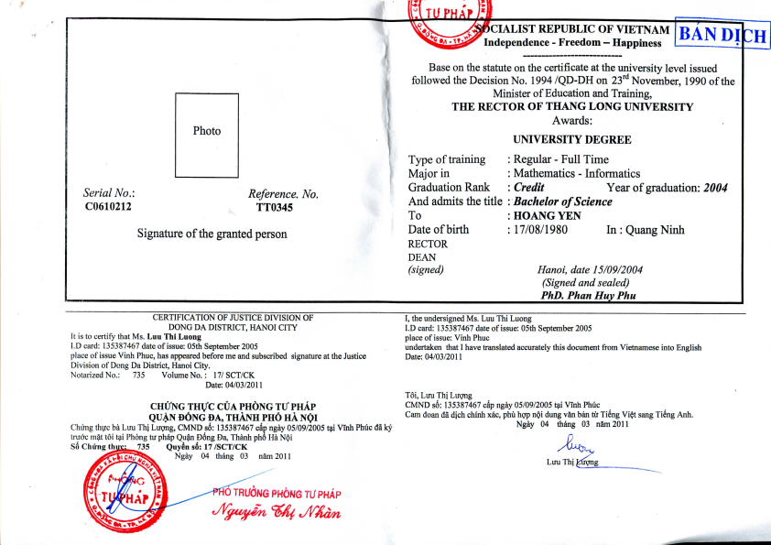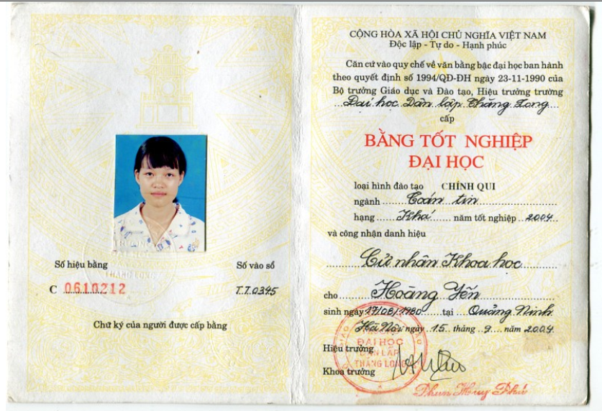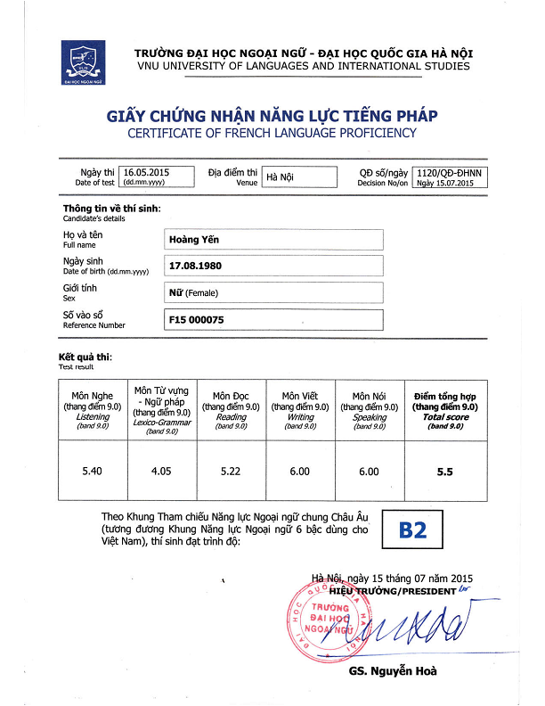

Certification successfully defended the informatics master's thesis, specialized: Networks and Communication on December 3, 2016 at IFI.

